Magic 8 Ball Tutorial
MIT App Inventor with Kodey Crandall

This step-by-step picture tutorial will guide you through adding sounds, images, and buttons to a mobile application.

To get started, go to App Inventor on the web (will not work with Microsoft Explorer).
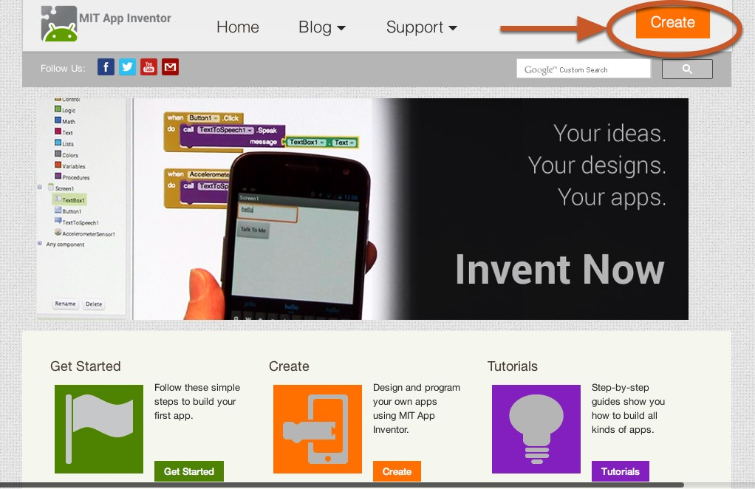
Go directly to ai2.appinventor.mit.edu, or click the orange "Create" button from the App Inventor website.

Log in to App Inventor with a Gmail (or google) user name and password.

Start a new project.
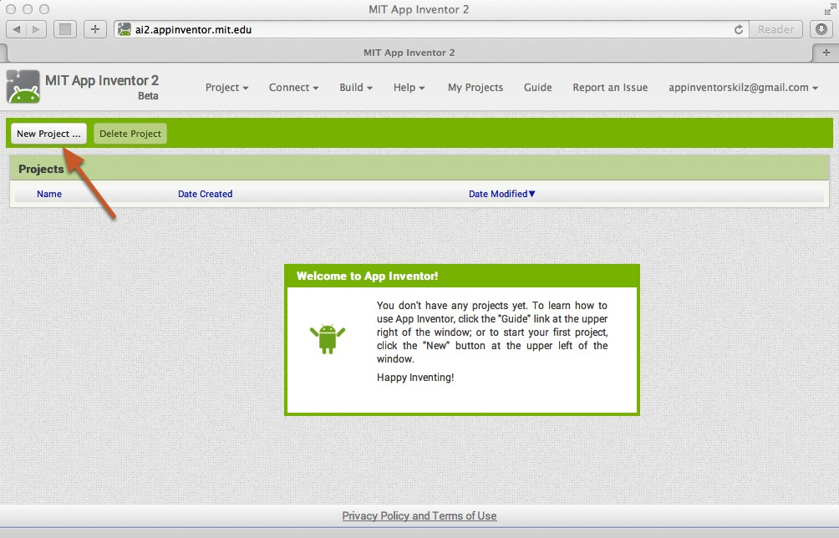

Name the project "Magic8Ball" (no spaces!)
Type in the project name (underscores are allowed, spaces are not) and click OK.

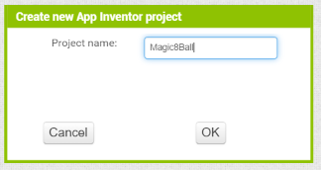

You are now in the Designer, where you layout the “user interface” of your app.
This app requires an image and button to show random text similar to the Magic 8 Ball. Let’s begin with the image. Audio sound files that will be used in this app can be downloaded from the website: kodeycrandall.com.

Add a Button
Our project needs a button that looks like a Magic 8 Ball. Click and hold on the word "Button" in the palette. Drag your mouse over to the Viewer. Drop the button and a new button will appear on the Viewer.

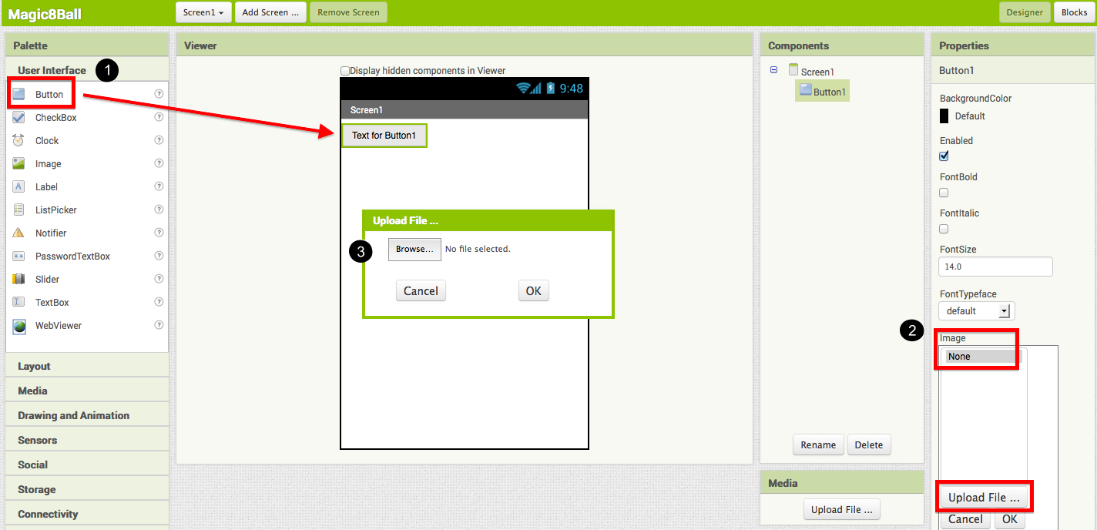

Connect App Inventor to your phone for live testing
Connect to the on-screen emulator or to your android device. If you are not sure how this is done, refer to tutorial 1 TalkToMePart1.
Select the menu Connect at the top of the screen and select Emulator or AI Companion.
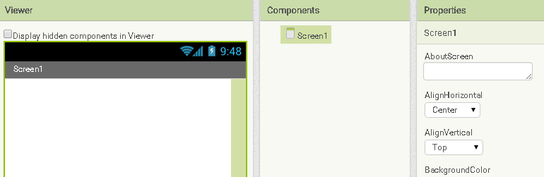

Align Horizontal for Screen1
To center the controls, you will need to align the content horizontally. To do this, click on the white space in the viewer and set the AlignHorizontal to “Center”.

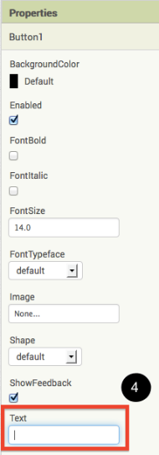

Change the button property
We need to set the button text property no text. This will allow us to add an image in for the button to look like a Magic 8 Ball without the button text over the image. Now we need to add an image to the button. Click on “None…” under image and find an image that looks like a Magic 8 Ball (You can download the image from http://www.kodeycrandall.com/magic-8.html).

Hint: You may need to adjust the height and/or width of the button so it is not too large or too small. To do this click “Automatic…” below the height or width and adjust it as needed.

Rename controls
Each control you add should have a unique name that you will refer to in the blocks. To rename the play button, go to the Components area, click on Button1, and then click the “Rename” below (Example: Button1 should be renamed to something like – btnMagic8Ball).

Add a Sound component to your app
Adding sound to an app requires three steps in the Designer.
- Select the Media drawer and drag the “Sound” control onto the Viewer. (It is a hidden component so it will appear at the bottom of the viewer.
- Attach the song to the Player
- Rename the “Sound” component to “Magic8Sound”
Hint: You will only need ONE Sound component for multiple sounds. We will just change the source when needed. Sound for this app can be found at http://www.kodeycrandall.com/magic-8.html
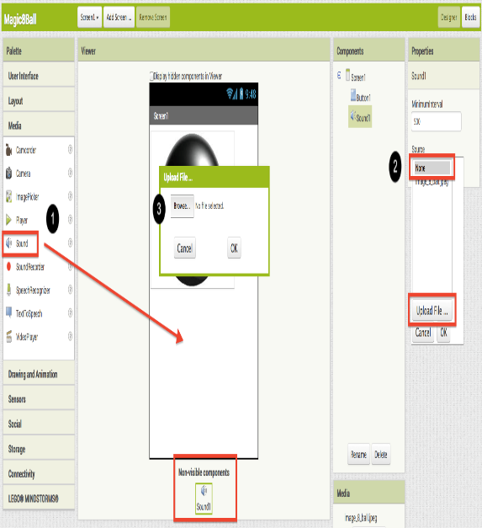

Switch over to the Blocks Editor
In the upper right corner of the Designer, click on the Blocks button.
Now you are going to tell your app how to behave when the button is clicked. This is actually very simple in App Inventor, because the "code" for the program only consists of two blocks!
Once the Blocks Editor is open, there are several options running along the left side of the screen. We refer to these as "Palettes" with “Drawers.”
From the blocks palette located under Screen1, click on the Button1 drawer. Drag the when btnMagic8Ball.Click block into the work area (#1). From the blocks palette, click on the Magic8Sound drawer, drag the Magic8Sound.Play block into the work area and insert it into the when btnMagic8Ball.Click block (#2). They will click together like magnetic puzzle pieces.

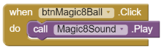
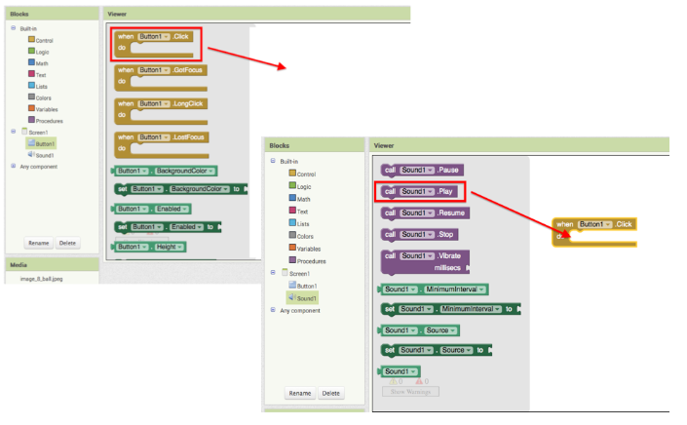
Your blocks should now look like this:

Save app space with HTML references
Because the app can only hold 5MB of space, you are limited to a certain point. To save space you can link content from online (remember, the user will need internet access).

Click the Button, Get a Prediction + Hear a Sound
Now that we've gotten the button to perform an action (play a sound), we want to extend that action to include giving the user a prediction. First we'll need two labels: Label1 will display the instructions, and Label2 will display the chosen prediction. We'll use blocks to program a "list picker" to choose from a list of predictions. Each time the button is clicked, the app will change the text of Label2 to display the chosen prediction.
DESIGN: App Inventor
Go back to the Designer window in your browser and add some new things to your app.
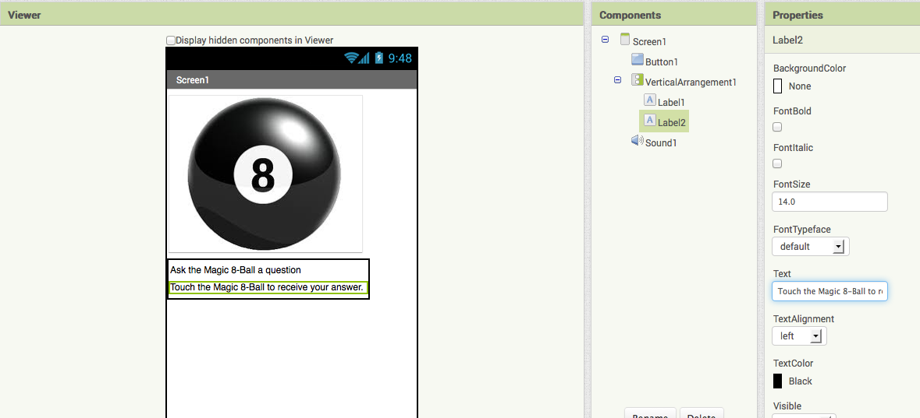
- From the Screen Arrangement palette, drag over the Vertical Arrangement component (#1). At first it will just look like an empty box, but when you put things in it, App Inventor will know that you want to line them up vertically (one on top of the other).

- From the Basic palette, drag over a Label component (#2) and drop it inside of the vertical arrangement component. In the Properties pane, change the "Text" property of Label1 to “Ask the Magic 8-Ball a question”.(#3)
- From the Basic palette, drag over another Label component (Label2) into the Vertical Arrangement box so that it sits right below Label1. Change the "Text" property of the Label2 to “Touch the Magic 8-Ball to receive your answer.” Now drag the 8-Ball image so that it is also inside the Vertical Arrangement component on top of the two labels. This will cause them to line up with each other in a vertical line. (Note: this can be tricky mouse work, but get them in there just right and the vertical arrangement will resize itself to fit everything.)
- Remember – You should rename your controls.

Back to Blocks Editor
Now for the fun part! You're going to make a list of predictions and program the button to pick one item from the list and display it inside Label2. The button will also still play the sound that you programmed in Part One. Here's how to do it...
- From the blocks palette, click on Label2 drawer to see all of its associated blocks. Drag over the green set lblTouchThe8Ball.Text and insert it just above the Magic8Sound.Play block. Notice that the when btnMagic8Ball.Click block automatically gets bigger to accommodate the new block.
- From the Built-In palette, click on the Lists drawer. Drag over the pick random item block and connect it to the open socket of the set lblTouchThe8Ball.Text block.
- From the Built-In palette, click on Lists again, then drag out the make a list block and plug it into the "list" socket on the right side of the pick random item block.
- From the Built-In palette, click on the Text drawer, drag out a " " block and connect it to the item socket of the make a list block. Click directly on the space in the block. You can then type in text there. Think about the sayings you want in your list of predictions for the Magic 8-Ball. Type the first prediction into this new text block.
- Notice after you plug in two text blocks, there are no more sockets to add more responses. To create more sockets, you need to click the dark blue button on the block. Make a list is called a mutator block and thus can be expanded or shrunk by clicking the blue button in the upper left corner. For a summary of mutators, check out the Mutators page

Blocks should look something like this:
Click here to add more items to the list
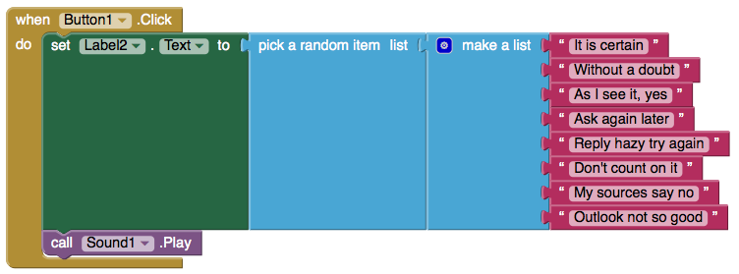

Change the image after song completes
Once the Player has played the complete song, you can have your app do something. Let say a student wants to ask a girl to the prom in a creative way. He can share this app with the girl he would like to ask, and as soon as the song is over, the image will change to a “Will you go to prom with me…” image. To do this we will first need to add another image to the application. Click upload in the media section and choose the custom image.
Next, you will need to click Image1 on the left and drag a “set Image1.Picture to” block in the “Player1.Completed” block. Lastly, you will need to drag a pick “blank” text block to the right of “set Image1.Picture to” and type in the name of the image you imported.

Test your cool new app!

